# Historical Value at Risk (VaR 95%) Analysis

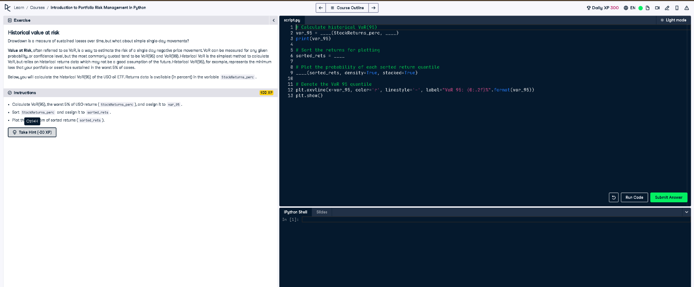

## Python Code

# Calculate historical VaR(95)  
var_95 = np.percentile(StockReturns_perc, 5)  
print(var_95)  
  
# Sort the returns for plotting  
sorted_rets = np.sort(StockReturns_perc)  
  
# Plot the probability of each sorted return quantile  
plt.hist(sorted_rets, density=True, stacked=True)  
  
# Denote the VaR 95 quantile  
plt.axvline(x=var_95, color='r', linestyle='-', label="VaR 95: {0:.2f}%".format(var_95))  
plt.show()

## Explanation

Value at Risk (VaR) estimates the worst expected loss over a period. We compute the 5th percentile (VaR 95%) of historical returns, sort them, and visualize their distribution. The red solid line shows the point where 5% of the worst losses begin—indicating potential risk exposure.